Name: M. Harshith Rao
Roll No: 2420090028
10.OWASP ZAP

- Download OWASP ZAP from
https://www.zaproxy.org/download/ and install it.
- Open OWASP ZAP and select the required session option.

- 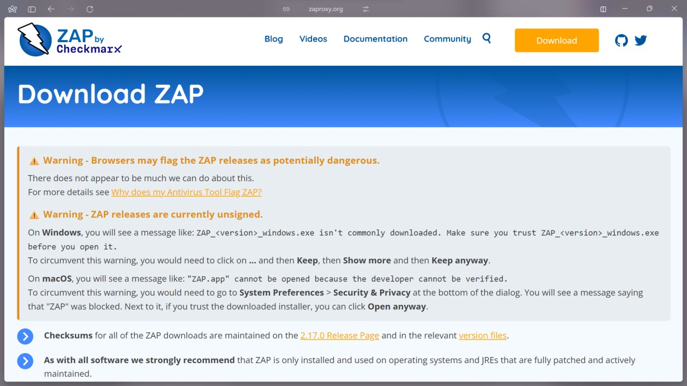

- Open Quick Start → Manual Explore.
- Enter the authorized test website URL in URL to explore.

- Select the browser and click Launch Browser.
- Browse the website and test its pages through ZAP.

- 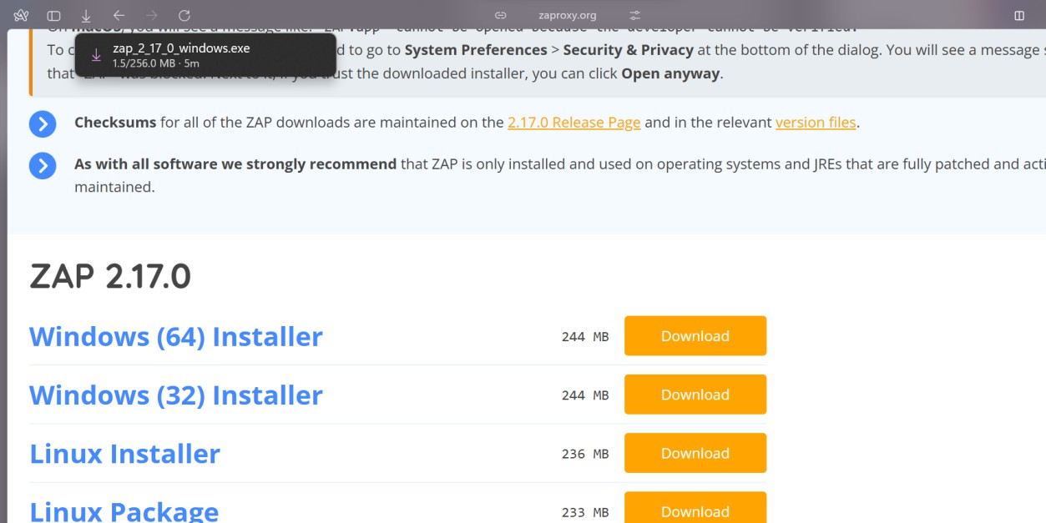

- Check the Sites panel and History tab for captured requests.

- 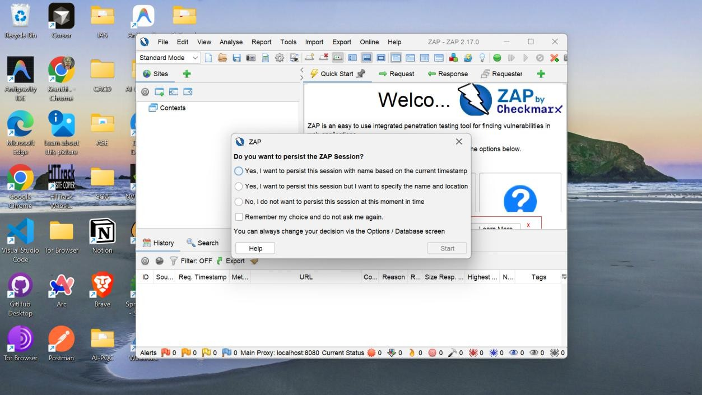

- Open the Alerts tab to view detected security issues.

- 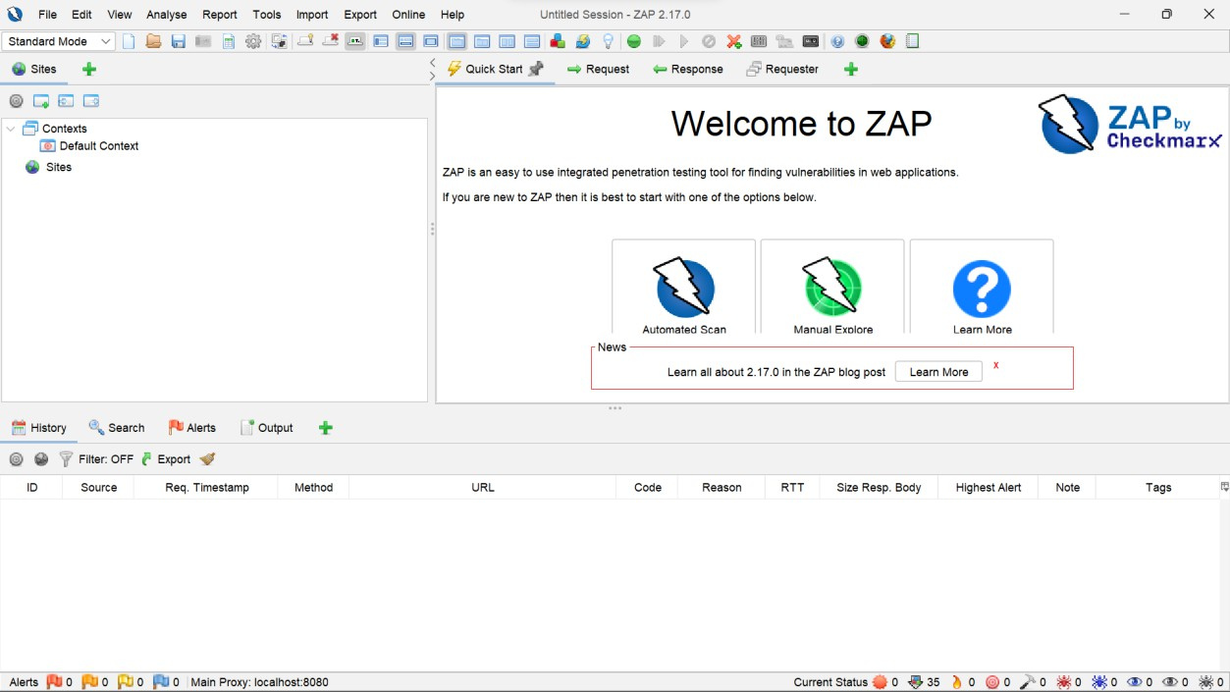

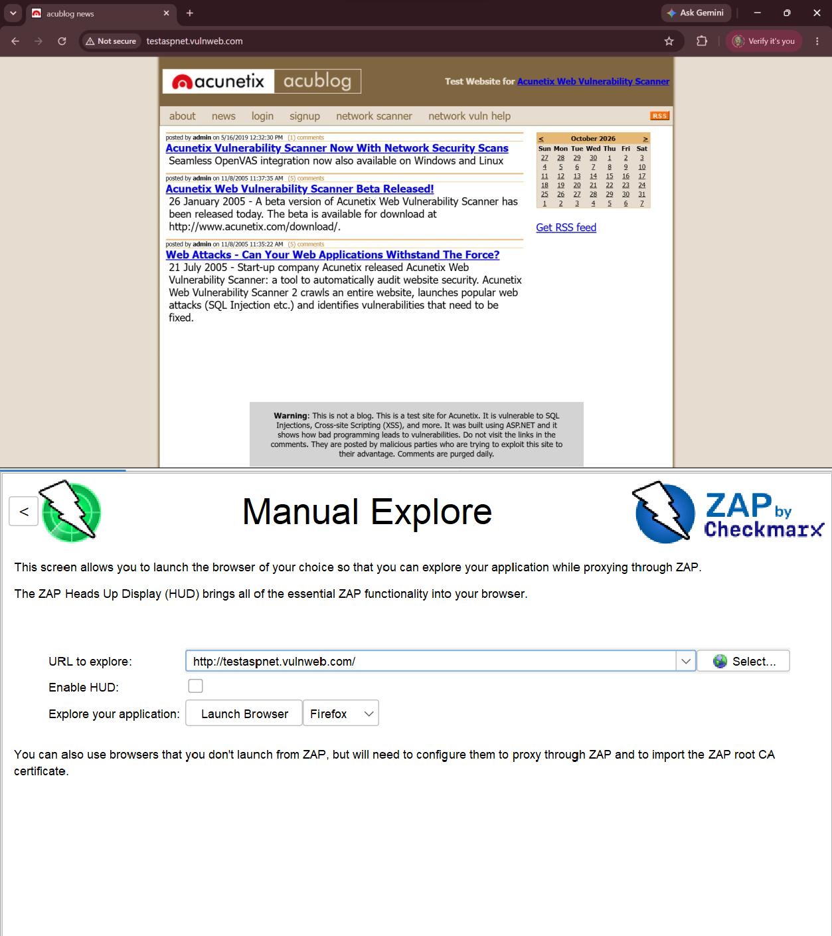
- Select Report → Generate Report, enter the report details, and generate the report.

- ​

- ​

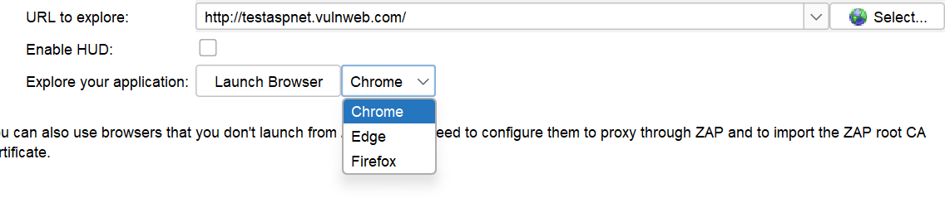
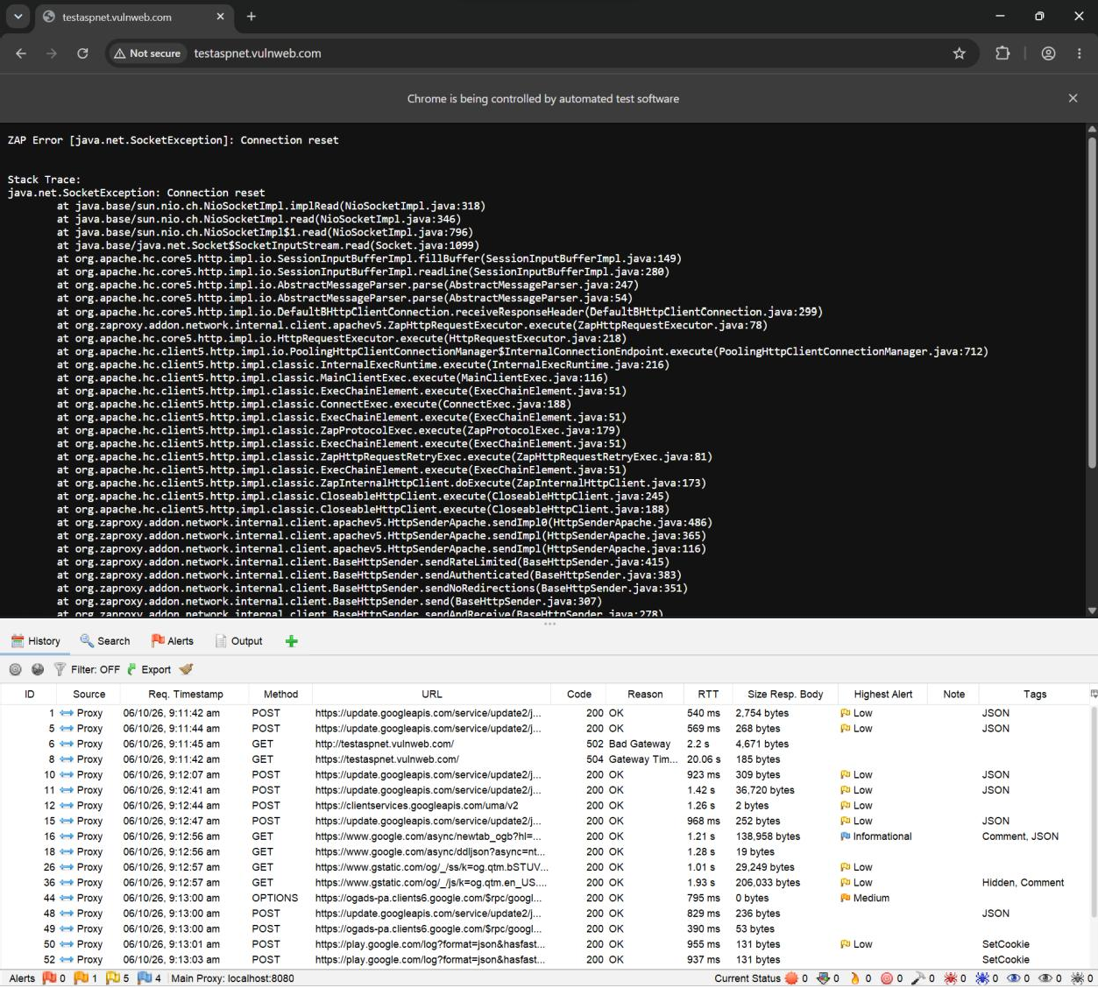
- ​

- ​

- ​

- 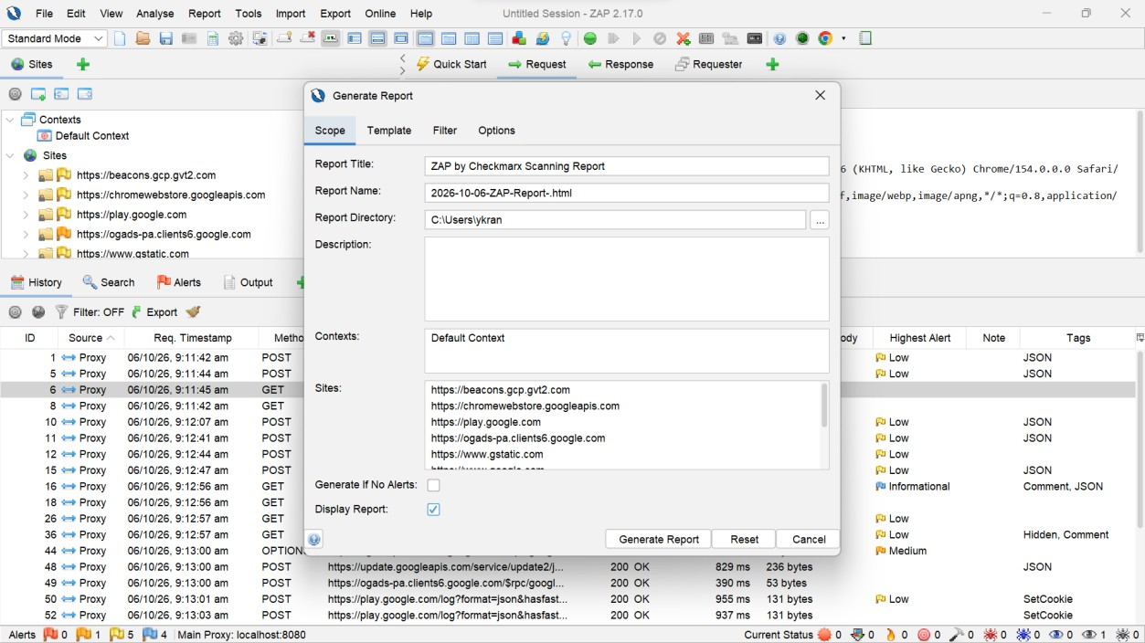
- Open the generated report and review
vulnerabilities, risk levels, and recommendations.

- 